Pokhara University

Level: Bachelor | Semester – Spring | Year : 2006
Programme: BE |  | Full Marks: 100
Course: Engineering Mathematics I |  | Time : 3hrs.

Candidates are required to give their answers in their own words as far as practicable.
The figures in the margin indicate full marks.

Attempt all the questions.

 | - Show that the function defined as follows  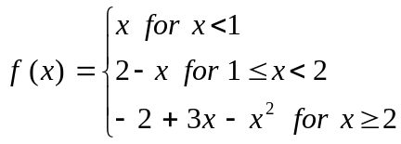  is continuous at x = 1 and x = 2 but is not differentiable at x = 1.  OR  If y = a cos (logx) + b sin (log x) show that  - 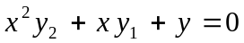  - 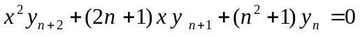  - State and prove Lagrange’s mean value theorem. Interpret it geometrically. Verify it for 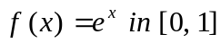. | 7  8
 | - A cylinder is inscribed in a given cone of height h. Find the height of the cylinder for which the volume is maximum.  - Evaluate 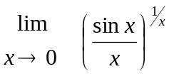  OR  Define curvature and radius of curvature of a function at a given point. Find the radius of curvature at (0, 0) of 4 x² – 3xy + y² – 3y = 0. | 8  7
 | Integrate Any Three of the following:  - 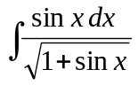 b) 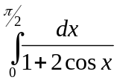  c) 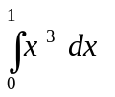(by summation method) d) 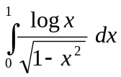 | 3×5
 | - Find the area between the curves x = y² and 2y² = - x + 3  OR  Find the volume of the solid in the region bounded by the curve x = y² and the line y = x - 2 revolved about y – axis.  - Find the approximate area using Simpson’s and Trapezoidal rules for the area bounded by curve y = x² + 3, the x-axis and the lines x = 1 and x = 5 (using n = 4) and compare these results with exact values. | 7  8
 | - If 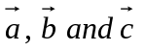are non coplanar (or coplanar) show that 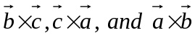are also non coplanar (or coplanar).  - Find by vector method the equation of the plane which passes through the points (1, 1, -1), (2, 0, 2) and (0, -2, 1). | 7  8
 | - Define eccentricity of a conic section and classify conic sections. Find the condition that the line lx + my + n = 0 may be a tangent to the ellipse 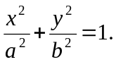  - Derive the equation of the hyperbola in its standard form 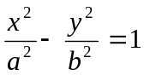 | 8  7
 | Attempt all the questions:  - Find the vertex, focus and line of symmetry of the parabola (y + 1)² = 8 ( x - 2)  - Obtain horizontal and vertical asymptotes of the curve y (x² - 1) +5 = 0  - Transform the equation x² – y² + 2x + 4y = 0 by transforming the origin to (-1, 2) where the coordinate axes remain parallel.  - Integrate 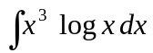  - Find the equation of the line passing through (1, 2, 3) and (3, 2, 7) by vector method. | 2×5

